**DAILY ONLINE ACTIVITIES SUMMARY**

|  |  |  |  |  |  |  |  |  |
| --- | --- | --- | --- | --- | --- | --- | --- | --- |
| **Date:** | **25/06/2020** | | | | | **Name:** | **Katira Krishna J** | |
| **Sem & Sec** | **8th A** | | | | | **USN:** | **4AL16CS045** | |
| **Online Test Summary** | | | | | | | | |
| **Subject** | | **SMS** | | | | | | |
| **Max. Marks** | | **30** | | **Score** | | | **Marks not received** | |
| **Certification Course Summary** | | | | | | | | |
| **Course** | **Deep Learning with TensorFlow** | | | | | | | |
| **Certificate Provider** | | | **Cognitiveclass.ai** | | **Duration** | | | **10 hours** |
| **Coding Challenges** | | | | | | | | |
| **Problem Statement: Python program to flatten a nested list using python** | | | | | | | | |
| **Status: Completed** | | | | | | | | |
| **Uploaded the report in Github** | | | | | **Yes** | | | |
| **If yes Repository name** | | | | | **Krishna_Katira** | | | |
| **Uploaded the report in slack** | | | | | **Yes** | | | |

Online Test Details:

No test Conducted

Certification Course Details:

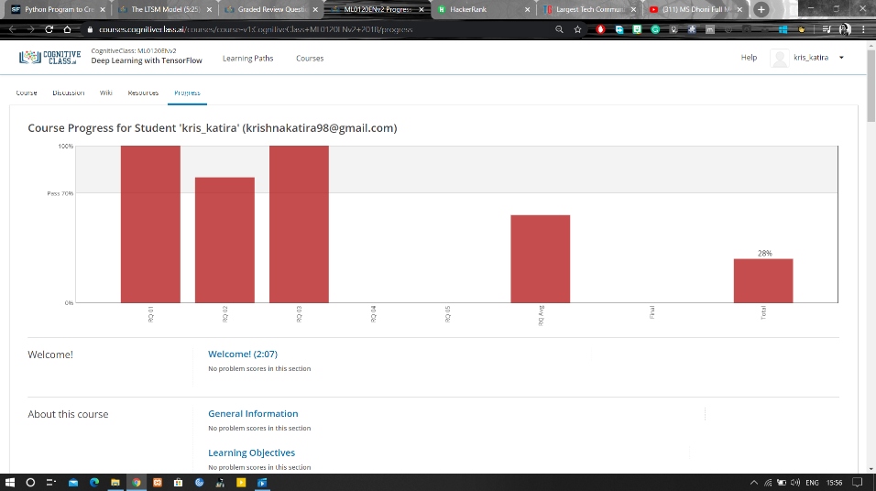

Coding Challenges Details:

**Program:**

def flatten(S):

if S == []:

return S

if isinstance(S[0], list):

return flatten(S[0]) + flatten(S[1:])

return S[:1] + flatten(S[1:])

s=[[1,2],[3,4]]

print("Flattened list is: ",flatten(s))